SCH4C October 2017
Measurements in Chemistry
MASS and VOLUME are the two most common measurements to make in chemistry.
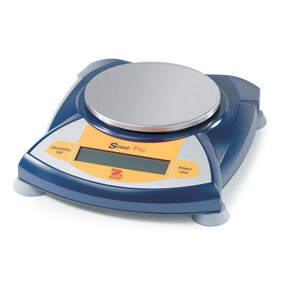 | Measures the __________________ of a substance
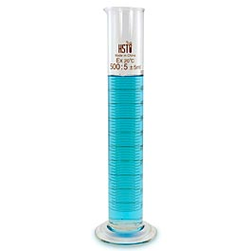 | Measures the ________________ of a substance.

Consider the 2 balances below:
The mass of the banana measures 186 g | The same banana might actually have a mass of 185.92 g or 186.25
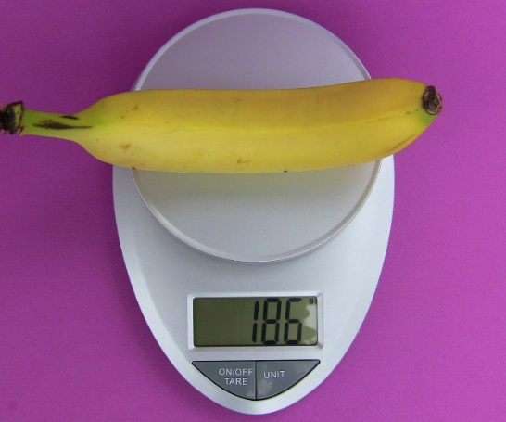 | 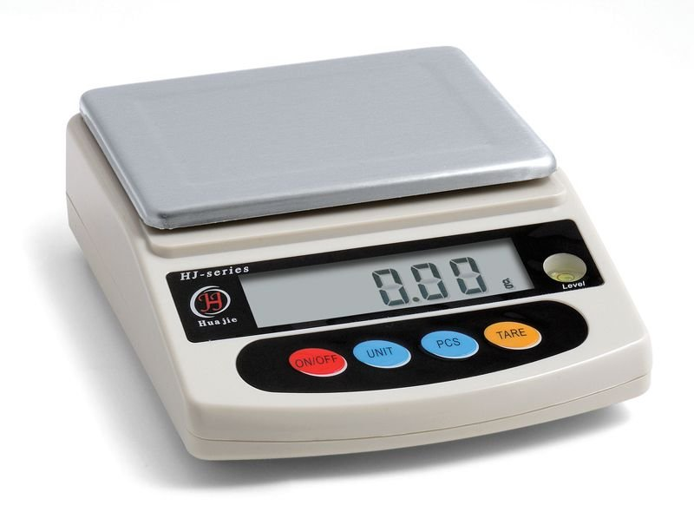

This leads us to the importance of recording down ALL measured values as well as the idea of significant digits.

RULE #1:
When adding or subtracting measured values, the answer has the same number of _____________________________ as the ______________ number of decimal places in the question.
Example:
2 objects are massed, one using balance 1 and the other using balance 2
Mass of object 1: 25 g
Mass of object 2: 13.45 g
The total of both masses is __________ g NOT ________ g
Why?
We don’t know what the decimal places would have been if object 1 had been massed on balance 2 – we can’t assume it was 25.00 g!
More examples:
10.1 g + 0.32 g =
5.56 g + 1.329 g =

Significant Digits
The number of digits that we are certain of (significant digits) depends on the ___________________ of the measuring device.
For example:
Using balance 1, the mass of the banana has been measured to _____ significant digits
Using balance 2, the mass of the banana has been measured to _____significant digits

How to determine the number of significant digits a measured value has:
- All non-zero digits are significant
186 has ______ significant digits; 185.89 has ______ significant digits
- The ONLY zero digits that are NOT significant are the ones leading up to a decimal point
0.632 has ______ significant digits; 0.00632 has ______ significant digits; 0.63200 has ______ significant digits 0.06302 has _______ significant digits

How many significant digits?
123.4
0.023
0.00030
8120.0
804
800
Round each number to the number of significant digits indicated:
0.3261 (to 3)
679.5 (to 3)
561 (to 2)
0.00344 (to 2)
540 (to 1)

RULE #2:
When multiplying and dividing measured values, the answer has the same number of ___________________________ as the ___________ number of significant digits in the question.

Using RULE #2:
Answer the following to the correct number of significant digits:
563 x 21 =
45/ 56.15 =
0.00123 x 0.115 =
0.702 x 1.20 =

